Campus Placement Prediction System

***Wireframe Documentation***

Homepage

Campus Placement System’s: -

1. First thing anyone will see is a pop-up window on Homepage which will ask for User Inputs like Stream, Internships CGPA ,Backlogs and Gender.

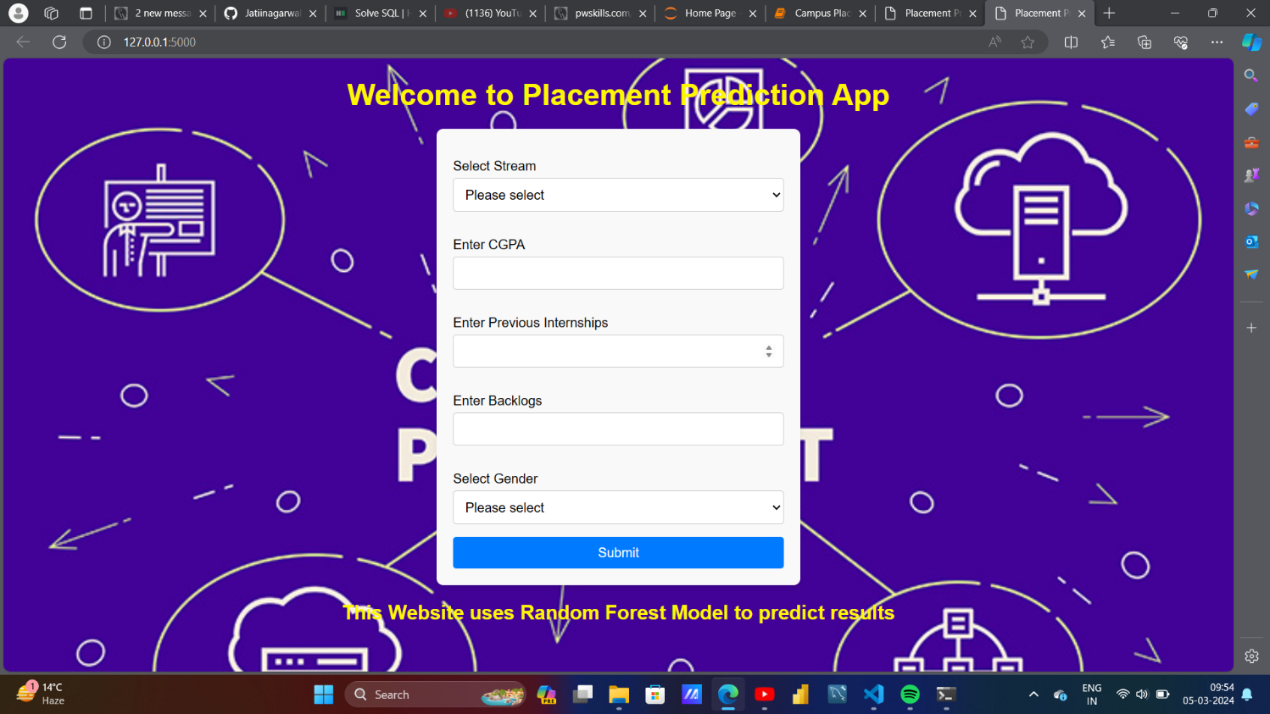

Based on User’s input, our Campus Placement Prediction System will Predict Output on Homepage itself. A sample view of Homepage showing results is below:

